The role of an encapsulin nanocompartment in resisting silver ion stress
Chong-Yang Xing^{1,2}, Teng-Fei Ma³, Jinsong Guo³, Yu Shen⁴, Peng Yan³, Fang Fang³, You-Peng Chen^{1,2,3,*}
¹Key Laboratory of Reservoir Aquatic Environment, Chongqing Institute of Green and Intelligence Technology, Chinese Academy of Sciences, Chongqing, 400714, China
² University of Chinese Academy of Sciences, Beijing, 100049, China
³ Key Laboratory of the Three Gorges Reservoir Region’s Eco-Environments of MOE, Chongqing University, Chongqing, 400045, China
⁴ National Base of International Science and Technology Cooperation for Intelligent Manufacturing Service, Chongqing Technology and Business University, Chongqing 400067, China.

Additional Information
The supplementary information includes:
Figures
Fig. S1. The express of cEnc in vitro.
Fig. S2. Setup and principle of plasmonic imaging of nanocompartment particles fell on a gold-coated glass sensor chip.
Fig. S3. Brightfield image of nanocompartment particles (with and without silver ion) .
Fig. S4. TEM images of encapsulin at acidic (pH 5), native (pH 7.5), and basic conditions (pH 9), revealing intact spherical particles under all conditio.
Fig. S5. Setup and principle of plasmonic imaging of bacterial cells fell on a gold-coated glass sensor chip.
Fig. S6. SDS–PAGE gels of bacterial total protein.
Fig. S7. Cell survival of E.coli with nanocompartment (black line) and without nanocompartment (red line) in the presence of different concentrations of ZnSO₄.
Table
Table. S1. The some protein (42kDa-45kDa) of the three groups samples (WB, WB+Ag+, GMB+Ag+).

Supplementary Experimental Section
Supplementary Figure
Fig. S1. The express of cEnc in vitro. (A) Representative SDS–PAGE gels of cEnc. (B) Amino acid sequence of the encapsulin shell proteins from Ca. Brocadia fulgida. Sequence fragments detected after tryptic digestion and MALDI-TOF MS analysis are shown in red. (C) Representative TEM micrographs of the purified nanocompartment. TEM analysis reveal that the purified encapsulin protein formed a shell-like nanocompartment with a diameter of 34 nm.

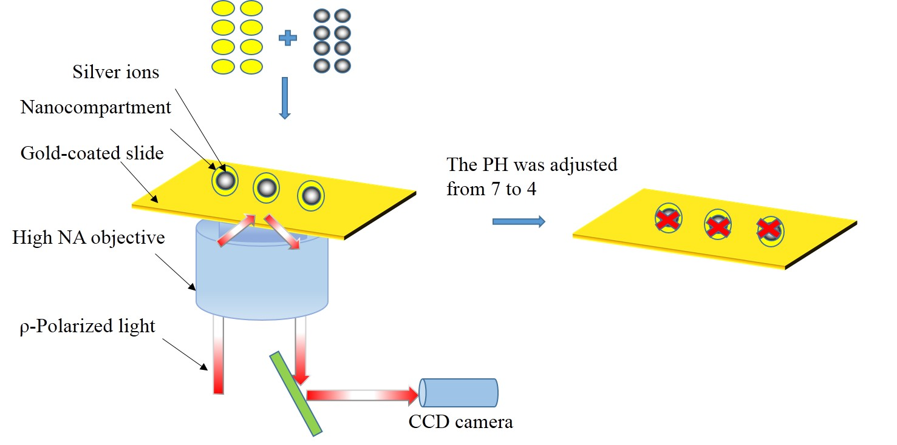
Fig. S2. Setup and principle of plasmonic imaging of nanocompartment particles fell on a gold-coated glass sensor chip. The polarized light is directed onto the sensor chip to create surface plasmons on the gold surface, and the reflected light is detected with a CCD to form plasmonic images. Brightfield transmission images of the nanocompartment particles are also simultaneously obtained with the same objective.

Fig. S3. (A) Brightfield image of nanocompartment particles (without silver ion). (B) Brightfield image of nanocompartment particles (with silver ion).

Fig. S4. TEM images of encapsulin at acidic (pH 5), native (pH 7.5), and basic conditions (pH 9), revealing intact spherical particles under all conditions[1].

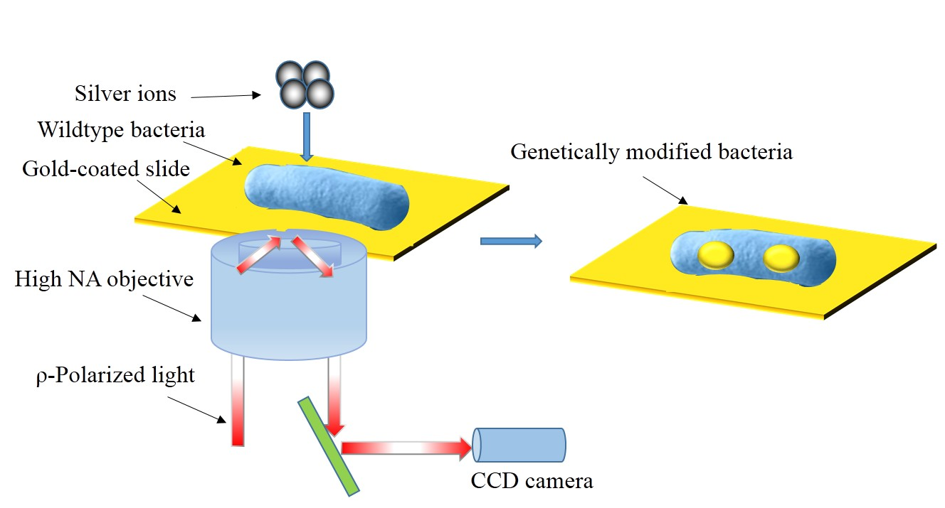
Fig. S5. Setup and principle of plasmonic imaging of bacterial cells fell on a gold-coated glass sensor chip. The polarized light is directed onto the sensor chip to create surface plasmons on the gold surface, and the reflected light is detected with a CCD to form plasmonic images. Brightfield transmission images of the bacterial cells are also simultaneously obtained with the same objective.

Fig. S6. SDS–PAGE gels of bacterial total protein. Line 1 was the wild-type bacteria 0µM AgNO₃. Line 2 was the genetically modified bacteria with 120µM AgNO₃. Line 3 was the wild-type bacteria 120µM AgNO₃.

Fig. S7. Cell survival of E. coli with nanocompartment (GMB, black line) and without nanocompartment (WB, red line) in the presence of different concentrations of ZnSO₄.

Table. S1. The some protein (42kDa-45kDa) of the three groups samples (WB, WB+Ag+, GMB+Ag+).
Accession_id | MW[kDa] | Abundance
Accession_id | MW[kDa] | WB | WB+Ag+ | GMB+Ag+
A0A080J1Y0 | 42 | 16554888.25 | 12332063 | 0
A0A070V333 | 42 | 70277702.33 | 78461104 | 0
W1FPE5 | 42.2 | 0 | 5832607.5 | 0
A0A3Z1VEY6 | 43.6 | 6154392.81 | 0 | 0
A0A447ZSS8 | 43.5 | 0 | 30334032 | 0
A0A3L0VUE1 | 43.7 | 24248003.91 | 4337332 | 0
A0A3S7BNN6 | 43 | 57106084.64 | 57131741 | 0
A0A377CU25 | 44.3 | 301470836.2 | 1770377216 | 0
A0A4U9LHG9 | 44.8 | 9200211.899 | 0 | 0
A0A080JH97 | 45.3 | 0 | 24983298 | 0
A0A377B7I5 | 45.5 | 31450315.35 | 11681428 | 0
A0A0K4PDV3 | 45.5 | 7220283.735 | 8301538.5 | 0
A0A377BAI1 | 45.6 | 0 | 9327480 | 0
A0A377AAV3 | 45 | 0 | 12650890 | 0

Supplementary Experimental Section
Protein expression
Protein expression was carried out by inoculating 50 mL LB medium (1:50) from an over-night culture. E. coli BL21 (DE3) was cultivated (37°C and 180 rpm) to an OD600 of 0.5 and then added IPTG (final concentration: 0.1 mM). Then cultures were grown at 30°C for 18 h and then harvested via centrifugation (4000 g, 10 min, 4°C). Cells were suspended in 5 mL 100 mM PBS buffer (pH 7.5) and lysed using a 550 Sonic Dismembrator (FisherScientific). Power level 3 was used with a pulse time of 10 sec. The time between pulses was 10 sec and total pulse time was 3 min. Subsequently, 10 µg/mL DNase I was added to the lysate followed by incubation on ice for 15 min. After cell debris was removed by centrifugation (8000 g, 10 min, 4°C). The cleared supernatant was then used either for protein affinity or purification.
TEM-EDX
The nanocompartment samples stored in a -80 °C degree refrigerator were remelted，Semi-thin sections (-250 nm) were collected on formvar-carbon-coated nickel square 50 mesh grids and analyzed with TEM-EDX for their elemental composition. Spot measurements were performed in the different compartments. Images were taken in the high-angle annular dark-field (HAADF)-mode.
SPR Image collection and processing
Clean BK7 glass coverslips were coated with 1.5 nm chromium and 47 nm gold and used as SPR sensing chips. The chips were cleaned with deionized water and ethanol for a few times, dried with nitrogen gas.The plasmonic imaging setup is based on the Kretschmann configuration with a high numerical aperture objective (NA 1.49) and an inverted microscope (Olympus IX-81) The sensor chip was placed on the objective lens with refractive index matching immersion oil. A 680 nm super luminescent diode (Qphotonics, Ann Arbor, MI) was used to excite the SPR images, and a CCD camera (Pike-032B, Allied Vision). The assembled gold chip was then mounted on top of the plasmonic imaging setup. The incident angle of the light beam was adjusted to the surface plasmon resonance angle, revealing minimal image intensity. All plasmonic imaging videos were collected at 1 fps at a pixel resolution of 640×480. We chose an appropriate exposure time to maximize image intensity at the same time avoiding over exposure. Images were subtracted from the first recorded image to remove background noises and interference patterns.
Proteomics
Protein extraction
Wild-type bacteria randomly chosen from the control group, high-dose AgNO₃ group, and genetically modified bacteria with high-dose AgNO₃ group were thawed on ice, and aliquots of the thawed samples were suspended in PBS (phosphate buffer saline) (Sigma-Aldrich, Shanghai, China) containing PMSF (phenylmethanesulfonyl fluoride) (Sigma-Aldrich, Shanghai, China). The solutions were centrifuged (14,000×g) againat 4 °C for 20 min to precipitate bacteria. Precipitates were collected and washed twice with PBS before suspension in lysis buffer (1% SDS (sodium dodecyl sulfate) (SigmaAldrich, Shanghai, China), 8 M urea, 1 mM PMSF) and disruption by sonication for 2 min on ice followed by incubation for 30 min on ice. The precipitates were collected by centrifugation (14,000×g, 8 °C, 8 min), re-suspended in 90% precooled acetone, and then left at −20 °C overnight for further protein precipitation. Extracts were then centrifuged for 10 min at 12,000×g to remove cell debris and any intact cells. Supernatants were carefully transferred to fresh tubes, and proteins were precipitated by methanol-chloroform precipitation. Dry pellets were stored at−80 °C until analyzed.
Protein digestion and LC-MS/MS measurements
For label-free experiments, bacteria protein samples were thawed on ice and digested according to the procedure described by Yin et al[2] with modifications. Protein aliquots (180μg) in lysis buffer (260 μl) were reduced in 10 mM TCEP (Tris(2-carboxyethyl)phosphine) (Thermo Fisher Scientific, Shanghai, China) at 37 °C for 60 min and alkylated with iodoacetamide (Sigma-Aldrich, Shanghai, China), added at a final concentration of 40 mM, at room temperature for 40 min. Then, cold acetone was added (6:1v/v), the mixture was precipitated at -20 °C for 4 h before centrifugation (10,000×g) for 20 min, and the pellets were collected. These were dissolved in 200 μl 100 mM TEAB (borane-triethylamine) (Sigma-Aldrich, Shanghai, China) before adding 1:50 (enzyme/protein) trypsin (Promega, Beijing, China), followed by digestion at 37 °C overnight. The peptides were vacuum dried, re-suspended in 2% acetonitrile and 0.1% TFA (trifluoroacetic acid) (Sigma-Aldrich, Shanghai, China), and desalted with Sep-Pak (Waters, Cat. WAT023590, Shanghai, China) before being vacuum dried. Peptide concentrations were determined with a peptide quantification kit (Thermo Fisher Scientific, Cat. 23275, Shanghai, China). Protein concentrations were determined using the bicinchoninic acidmethod (Beyotime Biotechnology, Shanghai, China).
Peptides were analyzed on a Q Exactive mass spectrometer (Thermo Fisher Scientific, Shanghai, China) coupled with Easy-nLC 1200. The peptides were loaded onto a C18-reversed phase column (Thermo Fisher Scientific, Shanghai, China) and eluted with a 2–80% acetonitrile + 0.1% formic acid gradient at a flow rate of 300 nl/min. The Q Exactive mass spectrometer was operated in the data-dependent mode to switch automatically between MS and MS/MS acquisition. Survey full-scan MS spectra (m/z350–1300) were acquired with a mass resolution of 70 K, followed by 20 sequential high-energy collisional dissociation MS/MS scans with a resolution of 17.5 K. In all cases, one microscan was recorded using a dynamic exclusion of 18 s. The mass spectrometry proteomic data were deposited in the ProteomeXchange Consortium via the PRIDE[3] partner repository with the dataset identifier PXD010972.
Taxonomic analysis of peptides and identification of proteins
MS/MS spectra were searched using Peaks Studio 8 software[4] against a bacteria database (44,716,473 sequences, downloaded on October 6, 2017) derived from the UniProt database (http://www.uniprot.org/) and a decoy database consisting of reverse protein sequences of the target sequences[5]. The highest score for a given peptide mass (best match to that predicted in the database) was used to identify parent proteins with the following settings: tryptic digestion with up to two missed cleavages, carbamidomethylation of cysteine as a fixed modification, and oxidation of methionine and protein N-terminal acetylation as variable modifications. Peptide spectral matches were validated based on qvalues at a 1% false discovery rate. A minimum of two unique peptides were required for protein identification. Protein quantification was carried out with Peaks Studio 8 software based on peak intensity (area).
Functional and enrichment analyses
Functional analyses of identified proteins were performed using gene ontology (GO) annotations (http://www.geneontology.org/), and the proteins were classified according to their biological processes, molecular functions, and cellular components. Proteins were further assigned to the Kyoto Encyclopedia of Genes and Genomes (KEGG) database (https://www.kegg.jp/). GO enrichment and KEGG pathway enrichment analyses were performed using Goatools (https://github.com/tanghaibao/GOatools)and
KOBAS (http://kobas.cbi.pku.edu.cn/home.do), respectively.
Statistical analysis
For GO enrichment and KEGG pathway enrichment analyses, the lists of proteins present in the control bacteria were compared to wild-type bacteria with high-dose AgNO3 group and genetically modified bacteria with high-dose AgNO₃ group. Differential proteins were used to perform enrichment tests of GO terms or KEGG pathways using two-tailed Fisher’s exact test method with a filter value of 0.05 in the FDR (false discovery rate) term filter mode and removal of duplicates.

References
1. Putri RM, Allende-Ballestero C, Luque D, Klem R, Rousou KA, Liu A, Traulsen CH, Rurup WF, Koay MST, Caston JR, Cornelissen J: Structural characterization of native and modified encapsulins as nanoplatforms for in vitro catalysis and cellular uptake. ACS Nano 2017, 11:12796-12804.
2. Yin X, Zhang Y, Liu X, Chen C, Lu H, Shen H, Yang P: Systematic comparison between SDS-PAGE/RPLC and high-/low-pH RPLC coupled tandem mass spectrometry strategies in a whole proteome analysis. Analyst 2015, 140:1314-1322.
3. Vizcaino JA, Csordas A, del-Toro N, Dianes JA, Griss J, Lavidas I, Mayer G, Perez-Riverol Y, Reisinger F, Ternent T, et al: 2016 update of the PRIDE database and its related tools (vol 44, pg D447, 2016). Nucleic Acids Res 2016, 44:11033-11033.
4. Zhang J, Xin L, Shan B, Chen W, Xie M, Yuen D, Zhang W, Zhang Z, Lajoie GA, Ma B: PEAKS DB: de novo sequencing assisted database search for sensitive and accurate peptide identification. Mol Cell Proteomics 2012, 11.
5. Elias JE, Gygi SP: Target-decoy search strategy for increased confidence in large-scale protein identifications by mass spectrometry. Nat Methods 2007, 4:207-214.

